**DEBT PRIMER**

Prepared by staff of the Texas Bond Review Board (April 2024)

Rob Latsha, Executive Director

# Introduction

The Texas Bond Review Board (BRB or Board) consists of the Governor, the Lieutenant Governor, the Comptroller of Public Accounts (voting members), and the Speaker of the House of Representatives (non-voting member). With the exception of Tax Revenue Anticipation Notes, State Highway Fund Revenue Anticipation Notes, Permanent University Fund issuances and non-general obligation issuances by university systems that have an unenhanced long-term rating of at least AA- or its equivalent, the BRB is responsible for the approval of all state debt issues and lease purchases with an initial principal amount of greater than $250,000 or a term of longer than five years. In addition, the BRB is responsible for collecting, analyzing, and reporting debt information for state agencies, state colleges and universities, and local political subdivisions in Texas. The BRB is also charged with the administration of the state’s Private Activity Bond Allocation Program. The BRB’s statutory authority is provided in Texas Government Code Chapters 1231 and 1372.

This Debt Primer is intended to provide basic knowledge of debt for government officials and other interested parties. It covers topics such as types of debt issued by the state of Texas, the state’s constitutional debt limit and policy implications of debt issuance. The Debt Primer concludes with a glossary of terms.

What is a Bond?

A bond is a *long-term* debt security issued to evidence a loan between a lender and a borrower specifying the:

* due date for the loan called the term or maturity, e.g. 20 years;
* interest rate, e.g. 5%;
* debt service (repayment) schedule, e.g. monthly, semi-annually, or annually; and
* revenue source pledged to repay the debt.

Common Terms for Debt Securities

* *Par* – 100% of the face value of a security.
* *Premium* – the amount by which the price paid for a security exceeds par value.
* *Discount* – the amount by which the price paid for a security is less than par value.
* *Maturity date* – the date the principal is due.
* *Coupon* – the interest rate paid on a security.
* *Fixed interest rate* – an interest rate that does not fluctuate during the life of a security.
* *Variable interest rate* – an interest rate that fluctuates based on a predetermined index or formula.
* *Liquidity* *Provider* – a financial intermediary that facilitates the remarketing of variable-rate debt at reset dates.
* *Yield* – the investor’s rate of return.

# Municipal Debt

Municipal debt is issued to finance any number of purposes for a governmental entity or institution of higher education. An investor who buys municipal debt is lending money to the issuer and receives a document evidencing the issuer’s promise to repay the principal plus a specified rate of interest during the life of the debt. Interest earned on municipal debt is usually exempt from federal income taxes.

Prior to issuance, the issuer usually hires both a **financial advisor** to advise on the structure and sale of the debt and **bond counsel** to provide a legal opinion that the issue meets all federal and state securities laws and that the debt is exempt from taxation.

The **underwriting syndicate** is a group of underwriting firms that buy the issue for resale to investors.

The **type of sale** is a critical component in the security sale process. Municipal securities are sold to underwriting firms through a competitive, negotiated, or private placement sale.

* In a *competitive sale* underwriting firm(s) submit sealed bids to purchase the securities, and the winning bidder is the firm(s) whose bid provides the lowest true-interest cost (TIC) and otherwise meets all specifications outlined in the Notice of Sale. A competitive sale helps achieve the lowest possible TIC but may reduce the issuer’s flexibility to change the terms and/or conditions of the sale. Competitive sales are best reserved for highly-rated issuers that have historically been well-received by investors.
* In a *negotiated sale* the issuer chooses an underwriting firm(s) prior to pricing to assist with structuring, documentation, and pre-sale of the securities to investors. At the time of sale, the issuer negotiates a price at which the securities are purchased for resale to investors. A negotiated sale provides the issuer with more flexibility to size and structure the sale than is available with competitive bids. Negotiated sales are best suited for issues that require a special selling effort either because the market is unfamiliar with the issuer or due to unique features of the issuance.
* A *private placement* is a negotiated offering in which an issuer’s securities are sold directly to a private investor(s) rather than through a public offering. Private placement investors are usually [banks](http://www.investopedia.com/terms/p/privateplacement.asp), mutual funds, insurance companies and pension funds and are generally smaller transactions than public sales.

If the municipal debt has a variable interest rate that resets at certain intervals after which the debt is remarketed, a **liquidity provider** is used to assure the market that the securities will be purchased in case of remarketing failure.

# Types of Debt Used

## *General Obligation (GO) Debt*

GO debt is legally secured by a constitutional pledge of the first monies coming into the State Treasury not constitutionally dedicated for another purpose and must be approved by a 2/3 vote of both houses of the legislature and a majority of the voters. GO debt may be issued in installments as determined by the legislatively appropriated debt service or by the issuing agency or institution and often has a 20-year maturity with level principal payments. The final maturity may depend on the useful life of the project to be financed. Examples include GO securities issued by the Texas Public Finance Authority (TPFA) to finance cancer research grants and GO securities issued by the Veterans Land Board to finance land and housing loans to qualified veterans.

## *Revenue Debt (non-General Obligation debt)*

Revenue debt is legally secured by a specific revenue source(s), does not require voter approval, and usually has a 20-year final maturity depending on the project to be financed. Examples include State Highway Fund bonds issued by the Texas Department of Transportation secured by the motor fuels tax and other revenues for construction and maintenance of the state’s highway system, and securities issued by institutions of higher education secured by tuition and fees used to finance projects such as classroom facilities, dormitories, and other university buildings.

## *Lease Purchases*

Lease purchases finance the purchase of an asset over time through lease payments that include principal and interest. They can be financed through a private vendor or through one of the state’s pool programs such as TPFA’s Master Lease Purchase Program. Lease purchase financings include equipment purchases such as automobiles, computers, data/telecommunications equipment, and equipment purchased for energy savings performance contracts.

## *Commercial Paper (CP)*

CP is a short-term debt obligation with a maturity not greater than 270 days. A CP program can be secured by the state’s general obligation pledge or by a specified revenue source(s). A CP program secured by the state’s general obligation pledge must be initially approved by 2/3 vote of both houses and a majority of the voters. When CP matures it can either be rolled-over (reissued) or refinanced (repaid) with long-term debt. Examples include CP issued by TPFA to finance its Master Lease Purchase Program and CP issued to finance the early stages of construction projects.

## *Tax and Revenue Anticipation Notes (TRANs)*

TRANs are notes issued by the Comptroller of Public Accounts – Treasury Operations to address cash flow shortfalls caused by the timing mismatch of revenues and expenditures in the general revenue fund. TRANs must be repaid by the end of the biennium in which they are issued but are usually repaid by the end of each fiscal year with tax receipts and other revenues of the general revenue fund.

*Permanent University Fund (PUF)*

The PUF is a public endowment that contributes to the support of institutions of The University of Texas System and The Texas A&M University System. The PUF was established by the Texas Constitution in 1876 through the appropriation of land grants previously given to The University of Texas at Austin plus one million acres. The BRB has no authority over PUF debt issuance.

## *Variable Rate Demand Obligations (VRDOs)*

VRDOs may be either general obligation or revenue obligations and generally have a stated maturity. The interest rate may be reset daily, weekly, monthly, or annually. The VRDOs are redeemable with specified (e.g. 7 days) notice at par (face value) at the holder’s [option](http://www.businessdictionary.com/definition/option.html) when the rate resets. If redeemed, the VRDOs are then resold by the remarketing agent in the secondary market to other investors. If the remarketing agent is unable to resell the VRDOs, a liquidity provider will buy the issue for later resale. Without a liquidity provider interest rates on VRDOs would be higher. Both the remarketing agent and the liquidity provider charge fees for their services. The Comptroller of Public Accounts acts as the liquidity provider for several of the state issuers.

## *Self-Supporting Debt*

Self-Supporting (SS) debt is designed to be repaid with revenues other than state general revenue and can be either GO debt or revenue debt. Revenue SS debt also includes conduit debt that is not an obligation of the state and is repaid from funds generated by a third-party borrower. For more information regarding conduit debt, see the BRB Fiscal Year 2023 State Debt Annual Report. Examples of self-supporting GO debt include Veterans Land Board bonds that are repaid from loan payments made by qualified veterans and related interest earnings, and GO bonds issued by the Texas Water Development Board that are repaid with loan payments made by political subdivisions for water projects and related interest earnings. Examples of self-supporting revenue debt include bonds issued by institutions of higher education that are repaid from tuition, fees and other revenues generated by colleges and universities and State Highway Fund Transportation Bonds.

## *Not Self-Supporting Debt*

Not self-supporting debt is intended to be repaid with state general revenues. Not self-supporting debt can be either general obligation debt or revenue debt. Not self-supporting GO debt is included in the Constitutional Debt Limit (see below). Examples of not self-supporting GO debt include TTC Highway Improvement (Prop 12) Transportation Bonds and TPFA Cancer Prevention and Research Bonds. Examples of not self-supporting revenue debt include Building Revenue Bonds (including the Capital Complex Project) and Certain Deferred Maintenance Projects both financed by TPFA.

# Texas Debt Outstanding

In fiscal year 2023, the state’s total debt outstanding (including conduit debt) increased 10.1 percent to $70.94 billion compared to $64.40 billion in fiscal year 2022 and $63.21 billion in fiscal year 2021. As of fiscal year-end 2023, $17.34 billion (24.4 percent) of the state's $70.94 billion in total debt outstanding was backed by the state’s GO pledge, an increase of $49.5 million (0.3 percent) from the $17.29 billion backed by the GO pledge at the end of fiscal year 2022.

Excluding conduit and component debt, $40.11 billion (56.5 percent) of the state's $70.94 billion in total debt outstanding as of fiscal year-end 2023 was backed by non-GO revenue pledges, an increase of $2.36 billion (6.3 percent) from the $37.75 billion backed by non-GO revenue pledges at the end of fiscal year 2022. Colleges and universities are the largest issuer of revenue debt with $17.15 billion outstanding, excluding Permanent University Fund (PUF) debt.

The debt totals below include commercial paper and variable rate notes but do not include short-term debt issued by the Comptroller of Public Accounts – Treasury Operations for cash management purposes (TRAN).

**Current Debt Outstanding (thousands)**



The chart below is Table 2.3 from the BRB State Debt Annual Report and shows the state’s debt outstanding by type over the past five years.



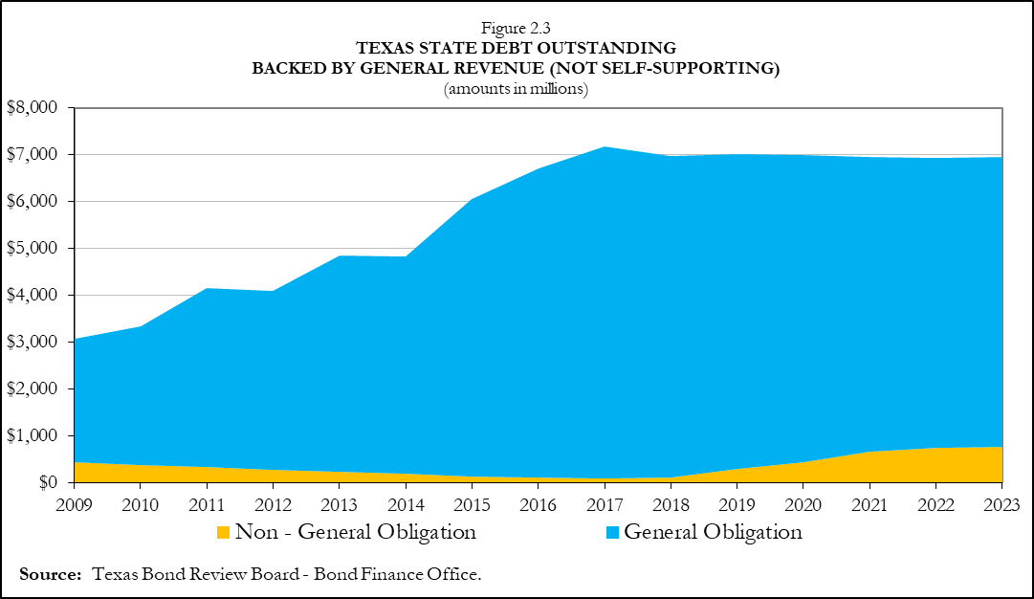The chart below is Figure 2.3 from the BRB State Debt Annual Report and shows a historical perspective of the state’s debt outstanding that is backed by the general revenue fund.

# Texas' Constitutional Debt Limit (CDL)

In 1997, the 75th Legislature passed, and voters approved, HJR 59, which added Section 49-j to Article III of the Texas Constitution. This amendment states that additional tax-supported debt may not be authorized if the maximum annual debt service on debt payable from general revenue, including authorized but unissued debt, exceeds 5 percent of the average annual unrestricted General Revenue Fund revenues for the previous three fiscal years.

As of August 31, 2023, Texas’ constitutional debt limit (CDL) remained below the maximum of 5 percent with 0.99 percent calculated for debt outstanding and 0.96 percent calculated for authorized but unissued debt for a total of 1.95 percent. Included in the CDL calculation is $143 million in revenue bonds authorized by the 88th Legislature for the Department of Motor Vehicles Camp Hubbard Renewal Project, the $767.7 million and $475.2 million of revenue bonds authorized by the 84th Legislature, 2015, and 86th Legislature, 2019 respectively, for the TFC Capitol Complex and North Austin Complex projects. Also included is the additional $3 billion for cancer research and $200 million for TWDB EDAP projects, both authorized by the voters at the November 2019 general election. Additional authorizations include $200 million for TWDB State Participation (SP) account projects (expiring September 1, 2024) and $208.8 million for HHSC deferred maintenance projects both authorized by the 86th Legislature, 2019. The 87th Legislature, 2021, authorized an additional $23.7 million for HHSC deferred maintenance projects and a $20 million bullion depository project, both of which are included in the CDL calculation.

Figure below shows the CDL percentages from FY 2009-2023.

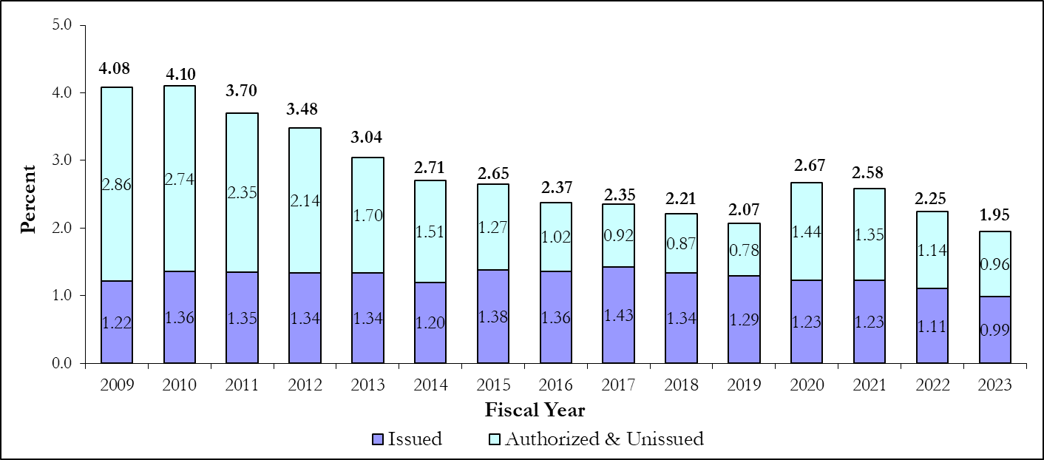

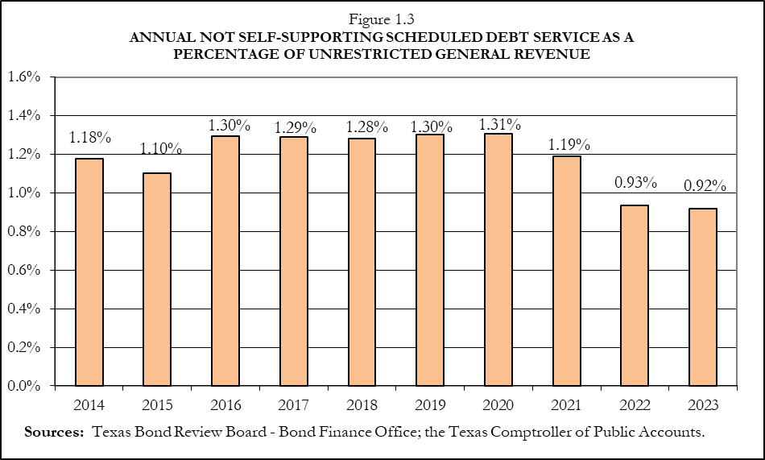Authorized but unissued debt (debt that has been authorized by the legislature and may be issued at any time without further legislative action) decreased very minimally by 0.70 percent from approximately $21.08 billion at the end of fiscal year 2022 to approximately $20.93 billion at the end of fiscal year 2023.

Of the $20.93 billion of authorized but unissued debt remaining as of fiscal year-end 2023, approximately $15.33 billion is GO debt and $5.60 billion is non-GO debt. Approximately $4.72 billion of the authorized but unissued amount is considered not self-supporting and includes GO and non-GO debt payable from general revenue.

## Ten Most Populous States

The most recent U.S. Census Bureau data for total state and local debt outstanding show that for census year 2021 (the most recent data available), Texas was the nation’s second most populous state and ranked third among the 10 most populous states in terms of local debt per capita, seventh in state debt per capita, and fourth in total state and local debt per capita (Table 1.6) with 83.8 percent of the state’s total debt burden at the local level. Listed by decreasing amount outstanding, local debt is issued by: Public School Districts; Cities, Towns, Villages; Water Districts and Authorities; Other Special Districts and Authorities; Counties; Community and Junior Colleges; and Health/Hospital Districts and Authorities.

# Bond Review Board Policies for State Debt Issuance, Derivative Agreements

HB 2190, passed in the 77thLegislature, directed the BRB to adopt formal debt policies and issuer guidelines to provide guidance to issuers of state securities and to ensure that state debt is prudently managed. These policies and guidelines are posted on the agency’s website.

SB 1332, passed in the 80thLegislature, amended the agency’s statutes to require the BRB to adopt a state policy related to the risks and effects of derivative agreements. This policy was adopted in fiscal year 2009 and is available on the agency’s website.

The 82nd Legislature 1st Called Special Session enacted Senate Bill (SB) 5 that exempts from BRB approval issuances by higher education institutions that have an unenhanced bond rating of AA- or higher and do not pledge the general revenue of the state. As of August 31, 2021, issuances for two higher education institutions, Texas Southern University and Texas State Technical College System require BRB approval.

# State Lending and Credit Support Programs

HB 1038, passed in the 88th Legislature, directed the BRB to prepare a biennial report on state lending and credit support programs due by December 31st of each even-numbered year. The BRB adopted Texas Administrative Code new rule 181.11 to grant the Board authority to gather relevant information from state agencies and political subdivisions to enable the Board to prepare the biennial report.

# Additional Information

The BRB created a debt data center website to be an informational and educational tool for decision makers and the general public to learn more about state and local government debt in Texas.

<https://data.brb.texas.gov/>

For more information on debt issuance in the state of Texas, please contact the Texas Bond Review Board at:

Texas Bond Review Board

300 West 15th Street, Suite 409

P.O. Box 13292

Austin, TX 78711

(512) 463-1741

(512) 475-4802 fax

[www.brb.texas.](http://www.brb.texas.)gov

[bondz@brb.texas.](mailto:bondz@brb.texas.)gov

**Glossary**

**Advance Refunding** – A refunding in which the refunded obligation remains outstanding for a period of more than 90 days after the issuance of the refunding issue. The Tax Cuts and Jobs Act of 2017 eliminated the option of issuing a tax-exempt advanced refunding of a tax-exempt municipal debt after December 31, 2017.

**Allocation** – The amount of private activity bond authority obtained from the state ceiling and assigned to a bond issuer using the issuance proceeds for a private activity that qualifies for exemption from federal income tax under the IRS Code.

**Allotment** – Amount of securities distributed to each member of the underwriting syndicate to fill orders.

**Authorized but Unissued** – Debt that has been authorized for a specific purpose by the voters and/or the legislature but has not yet been issued. Authorized but unissued debt can be issued without the need for further legislative action.

Bond – A debt instrument in which an investor loans money to the issuer that specifies when the loan is due (“term” or “maturity” such as 20 years), the interest rate the borrower will pay (such as 5 percent), when the debt-service payments will be made (such as monthly, semi-annually, or annually), and the revenue source pledged to make the payments.

**Bond Counsel** – Attorney retained by the issuer to give a legal opinion that the issuer is authorized to issue the proposed securities, the legal requirements necessary for issuance have been met, and the proposed securities will be exempt from federal income taxation and state and local taxation where applicable.

**Bond Insurance** – A legal commitment by an insurance company to make timely payments of principal and interest in the event that the issuer of the debt is unable to make the payments.

**Bond Proceeds** – The money paid to the issuer by the purchaser or underwriter of a new issue of municipal securities. These funds are used to finance the project or other purpose for which the securities were issued and to pay certain costs of issuance as may be provided in the bond contract or bond purchase agreement.

**Build America Bonds** **(BABs)** – A debt instrument created by the American Recovery and Reinvestment Act of 2009 (ARRA) that could be issued as Tax Credit BABs or Direct-Payment BABs. Tax Credit BABs provide a tax credit to investors equal to 35 percent of the interest payable by the issuer. Direct-Payment BABs provide a direct federal subsidy payment to state and local governmental issuers equal to 35 percent of the interest payable. After the implementation of the Budget Control Act of 2011, the BAB subsidies were reduced. Authority to issue BABs expired in December 2010. See table below for a history of sequestration rates.

|  |  |
| --- | --- |
| **Federal Fiscal Year**  **(October 1st thru September 30th)** | **Sequestration Rate Reduction** |
| 2021-2030 | 5.7% |
| 2020 | 5.9% |
| 2019 | 6.2% |
| 2018 | 6.6% |
| 2017 | 6.9% |
| 2016 | 6.8% |
| 2015 | 7.3% |
| 2014 | 7.2% |
| 2013 | 8.7% |

**Capital Appreciation Bonds (CABs)** – A municipal security in which the investment return (interest) on an initial principal amount is reinvested at a stated compounded rate until maturity. At maturity, the investor receives a single payment (the “maturity value”) representing both the initial principal amount and the total investment return.

**CAB Maturity Amount** – The single payment for a capital appreciation bond an investor receives at maturity, representing both the initial principal amount and interest. For capital appreciation bonds, compound accreted values are calculated as interest in the year of maturity.

**CAB Par Amount** – The face amount assigned to a capital appreciation bond at issuance and paid to the investor at maturity.

**CAB Premium** – The amount by which the price paid for a (CAB) security exceeds par value.

**Capital Construction Assistance Project (CCAP)/Tuition Revenue Bonds (TRB)** – Revenue bonds issued by the revenue finance systems of institutions of higher education or the Texas Public Finance Authority (on behalf of certain institutions) for new building construction or renovation. The legislature must authorize the projects in statute, and the CCAPs/TRBs cannot be used for auxiliary space, such as dormitories. All college and university revenue bonds are equally secured by and payable from a pledge of all or a portion of certain “revenue funds” as defined in the Texas Education Code, Chapter 55. Though legally secured through an institution’s tuition and fee revenue, historically, the state has used general revenue to reimburse the universities for debt service for these bonds.

**Carryforward** – A private activity bond term for the three types of state ceiling that can be carried over for use by an issuer in the subsequent three years. The three types are:

1. Traditional Carryforward - The amount of the state ceiling not reserved before November 15 and any amount previously reserved that becomes available on or after that date because of a reservation cancellation.
2. Non-Traditional Carryforward - The amount of state ceiling reserved by an issuer for a specific purpose and for which the closing date extends beyond the year in which the reservation was granted.
3. Unencumbered Carryforward - The amount of state ceiling at the end of the year that is not reserved nor designated as carryforward, and for which no application for carryforward is pending.

**Certificate of Obligation** **(CO)** – A obligation issued by a city, county, or certain hospital districts without the approval of voters to finance public projects. Although voter approval is not required, the sale can be stopped if 5 percent of the total voters in the taxing area sign a petition and submit it prior to approval of the ordinance to sell such certificates.

**Certificate of Participation (COP)** – A tax-exempt, lease-financing agreement used by a municipality or local government in which an [in](http://www.businessdictionary.com/definition/individual.html)vestor [buys](http://www.investorwords.com/636/buy.html) a [share](http://www.investorwords.com/4525/share.html) or participation in the revenue generated from the lease-purchase of the property or equipment to which the COP is tied. COPs do not require voter approval.

**Charter School** – Charter schools were created by the Texas Legislature in 1995 as part of the public school system. Under Texas Education Code, Chapter 12, the purpose of charter schools is to improve student learning, increase the choice of learning opportunities within the public school system, create professional opportunities that will attract new teachers to the public school system, establish a new form of accountability for public schools, and encourage different and innovative learning methods.

**Commercial Paper** –Short-term, unsecured promissory notes that mature within 270 days and are backed by a liquidity provider (usually a bank) that stands by to provide liquidity in the event the notes are not remarketed or redeemed at maturity.

**Competitive Sale** – A sale in which the issuer solicits bids from underwriting firms and sells the securities to the underwriter or syndicate offering the most favorable bid that meets the specifications of the notice of sale.

**Component Unit (CU)** –A legally separate entity for which the elected officials of the primary government (PG) are financially accountable. The nature and significance of the CUs relationship with the PG is such that exclusion from the PG’s financial reports would be misleading or create incomplete financial statements.

**Conduit Debt** – Per the Governmental Accounting Standards Board (GASB), conduit debt obligations are issued by a state or local governmental entity for the express purpose of providing financing for a specific third party that is usually not a part of the issuer’s financial reporting entity. GASB’s most recent development of its definition of a conduit debt obligation states the key characteristic should be that there are at least three participants: the government issuer, the third-party borrower, and the bondholder. Although conduit debt obligations bear the name of the governmental issuer, the issuer has no obligation for such debt beyond the resources provided by a lease or loan with the third party on whose behalf they are issued.

**Conduit Issuer** – An issuer, usually a government agency, that issues municipal securities to finance revenue-generating projects in which the funds generated are usually used by a third party (known as the conduit borrower or obligor) for debt-service payments.

**Costs of Issuance** – The expenses associated with the sale of a new issue of municipal securities, including underwriting costs, legal fees, rating agency fees, and other fees associated with the transaction.

**Counterparty Risk** –The risk to each party in a swap contract that the counterparty will not fulfill its contractual obligations.

**Coupon** – The interest rate paid on a security.

**Current Interest Bond (CIB)** – A bond in which interest payments are made on a periodic basis throughout the life of the bond as opposed to a bond (such as a capital appreciation bond) that pays interest only at maturity. This term is most often used in the context of a combination issuance of bonds that includes both capital appreciation bonds and current interest bonds.

**Current Refunding** –A refunding transaction in which the municipal securities being refunded will mature or be redeemed within 90 days or less from the date of issuance of the refunding issue.

**CUSIP** – A unique nine-character identification for each class of security approved for trading in the United States. CUSIPs are used to facilitate clearing and settlement for market trades.

**Dealer Fee** – Cost of underwriting, trading, or selling securities.

**Debt Outstanding** – The amount of unpaid principal on a debt that will continue to generate interest until paid off.

**Debt per Capita** – A measurement of the value of a government's debt expressed in terms of the amount attributable to each citizen under the government's jurisdiction. The formula is the debt outstanding as of August 31 divided by the estimated residential population of the issuer.

**Debt Service** – The amount that is required to cover the repayment of principal and interest on a debt for a particular period.

**Defeasance** – A provision that voids a debt when the borrower sets aside cash, securities, or investments sufficient to service the borrower's debt.

**Derivative** – A financial instrument whose value is based on one or more underlying assets. An example is a swap contract between two counterparties that specifies conditions (especially the dates, underlying variables, and notional amounts) under which payments are to be made between the parties.

**Disclosure** – The act of releasing accurately and completely all material information to investors and the securities markets for outstanding or to be issued securities.

**Disclosure Counsel** – An attorney or law firm retained by the [issuer](http://www.msrb.org/glossary/definition/issuer.aspx) to provide advice on issuer disclosure obligations and to prepare the official statement and/or continuing disclosure agreement.

**Discount** – The amount by which the price paid for a security is less than its par value.

**Escrow** – Fund established to hold monies or securities pledged to pay debt service.

**Escrow Agent** – Commercial bank or trust company retained to hold the investments purchased with the proceeds of an advance refunding and to use the invested funds to pay debt service on the refunded debt.

**Financial Advisor** – A securities firm that assists an issuer on matters pertaining to a proposed issue such as structuring, timing, marketing, fairness of pricing, terms, and debt ratings.

**Fiscal Year** – Information is sorted on the fiscal year of the state, September 1 through August 31. Debt-service adjustments have been made for local governments with different fiscal years. Information is provided on cash, not accrual basis.

**Fixed Rate** – An interest rate that does not change during the entire term of the obligation.

**Forward or Forward Contract** – A contract (variously known as a forward contract, forward delivery agreement, or forward purchase contract) wherein the buyer and seller agree to settle their respective obligations at some specified future date based upon the current market price at the time the contract is executed. A forward may be used for any number of purposes. For example, a forward may provide for the delivery of specific types of securities on specified future dates at fixed yields for the purpose of optimizing the investment of a debt-service reserve fund. A forward may provide for an issuer to issue and an underwriter to purchase an issue of bonds on a specified date in the future for the purpose of effecting a refunding of an outstanding issue that cannot be advance refunded.

**General Obligation (GO) Debt** –Debt legally secured by a constitutional pledge of the first monies coming into the State Treasury not otherwise constitutionally dedicated for another purpose. General obligation debt must be approved by a two-thirds vote of both houses of the Texas Legislature and by a majority of the voters.

**General Revenue (GR)** – The amount of total state tax collections and federal monies distributed to the state for its operations.

**Higher Education Fund (HEF)** – Appropriations that became available beginning in 1985 through Constitutional Amendment to fund permanent capital improvements for certain public higher education institutions. This term may refer either to Higher Education Assistance Fund (HEAF) Treasury Funds (funds reimbursed from the State HEAF appropriation for university expenditures) or HEAF Bond Funds (monies received through the issuance of bonds and secured by HEAF Treasury Funds). 

**Indenture** – Deed or contract, which may be in the form of a resolution, that sets forth the legal obligations between the issuer and the securities holders. The indenture also names the trustee that represents the interests of the securities holders.

**Issuer** – A legal entity that sells securities for the purpose of financing its operations. Issuers are legally responsible for the obligations of the issue and for reporting financial conditions, material developments, and any other operational activities.

**Lease Purchase** – Financing the purchase of an asset over time through lease payments that include principal and interest. Lease purchases can be financed through a private vendor or through one of the state's pool programs such as the Texas Public Finance Authority’s Master Lease Purchase Program.

**Lease-Revenue Bonds** – Bonds issued by a nonprofit corporation or government issuer, that are secured by lease payments made by the government or third-party borrower for use of specified property.

**Letter of Credit** –A credit enhancement used by an issuer to secure a higher rating for its securities. A letter of credit is usually a contractual agreement between a major financial institution and the issuer consisting of an unconditional pledge of the institution’s credit to make debt-service payments in the event of a default.

**Liquidity** – The relative ability of a security to be readily traded or converted into cash without substantial transaction costs or loss in value.

**Liquidity Provider** – A financial institution that facilitates the trading of a security by insuring that it will be purchased if tendered to the issuer or its agent because it cannot be immediately remarketed to new investors.

**Management Fee** – A component of the underwriting spread that compensates the underwriters for assistance in creating and implementing the financing.

**Maturity Date** – The date principal is due and payable to the security holder.

**Mortgage Credit Certificate** – A [certificate](http://en.wikipedia.org/wiki/Certificate) issued by certain [state](http://en.wikipedia.org/wiki/U.S._state) or local [governments](http://en.wikipedia.org/wiki/Government) that allows a taxpayer to claim a [tax credit](http://en.wikipedia.org/wiki/Tax_credit) for some portion of the [mortgage](http://en.wikipedia.org/wiki/Mortgage_loan) [interest](http://en.wikipedia.org/wiki/Interest) paid during a given tax year.

**Municipal Bond** – A debt security issued to finance projects for a state or local government issuer. Municipal securities are typically exempt from federal taxes and from most state and local taxes.

**Negotiated Sale** – A sale in which an issuer selects an underwriting firm or syndicate to assist with the issuance process. At the time of sale, the issuer negotiates a purchase price for its securities with that underwriting firm or syndicate.

**Not Self-Supporting Debt** – Either general obligation or revenue debt intended to be repaid with state general revenues.

**Notice of Sale** – Publication by an issuer describing the terms of sale of an anticipated new offering of municipal securities.

**Official Statement** – The document published by the issuer that provides complete and accurate material information to investors on a new issue of municipal securities, including the purposes of the issue, repayment provisions, and the financial, economic, and social characteristics of the issuing government.

**Par** – The face value of a security that is due at maturity. A “par bond” is a bond selling at its face value.

**Paying Agent** – The entity responsible for processing debt-service payments from the issuer to the security holders.

**Permanent School Fund (PSF)** – The PSF was created in 1854 by the 5th Legislature expressly for the benefit of public schools. In addition, the Texas Constitution of 1876 stipulated that certain lands and proceeds from the sale of those lands would also be dedicated to the PSF. The Texas Constitution requires that distributions from the returns on the PSF be made to the Available School Fund to be used for the benefit of public and charter schools and allows the PSF to be used to guarantee bonds issued by public and charter schools.

**Permanent School Fund Bond Guarantee Program (BGP)** – The BGP was created in 1983 as an alternative for school districts to avoid the cost of private bond insurance by obtaining a PSF guarantee for voter-approved public school bond issuances. To qualify for the BGP guarantee, school districts and charter schools must be accredited by the state, have investment-grade bond ratings (but below AAA), and have their applications approved by the Commissioner of Education. Bonds guaranteed by the BGP are rated AAA.

**Permanent University Fund** **(PUF)** – The PUF is a state endowment contributing to the support of 21 institutions and certain agencies of The University of Texas System and The Texas A&M University System. The PUF was established by the Texas Constitution in 1876 with land grants ultimately totaling 2.1 million acres primarily in West Texas (PUF Lands).

**Premium** – The amount by which the price paid for a security exceeds par value.

**Premium Capital Appreciation Bond (PCAB)** – A type of CAB that has a stated yield or accretion rate that is higher than its actual current yield to investors. This difference results in a lower initial stated par amount, which preserves debt capacity.

**Principal** – The face value of a bond, exclusive of interest.

**Printer** – A business that produces the official statement, notice of sale, and any bonds required to be transferred between the issuer and purchasers of the bonds. The costs associated with a printer are typically rolled into the Costs of Issuance.

**Private Activity Bond (PAB)** – A tax-exempt bond issued by or on behalf of local or state government for the purpose of financing the project of a private user, and generally, the government does not pledge its credit.

**Private Placement** – A securities sale in which an issuer sells its securities directly to investors through a placement agent without a public offering.

**Put Bond** – A bond that allows the holder to force the issuer to repurchase the security at specified dates before maturity. The repurchase price is set at the time of issue and is usually par value.

**Qualified Energy Conservation Bonds (QECB)** – A bond that enables qualified state, tribal, and local government issuers to borrow money at attractive rates to fund energy conservation projects. While not a grant, a QECB is among the lowest cost public financing tools available because the U.S. Department of the Treasury subsidizes the issuer's borrowing costs.

**Rating Agency** – An entity that provides publicly available ratings of the credit quality of securities issuers, measuring the probability of the timely repayment of principal and interest on municipal securities.

**Refunding Bond** – A bond issued to retire or defease all or a portion of outstanding bonds.

**Registrar** – An entity responsible for maintaining ownership records on behalf of the issuer.

**Remarketing Fee** – Compensation to an agent for remarketing a secondary offering of short-term securities, usually for a mandatory or optional redemption or put (return of the security to the issuer).

**Reservation** – The notice given by the BRB to a private activity bond issuer reserving a specific amount of the state ceiling for a specific issue of bonds for 150 to 210 days, depending on the type of bond issuance.

**Revenue Debt** – Debt that is legally secured by a specified revenue source(s). Revenue debt does not require voter approval and usually has a maturity based on the life of the project to be financed.

**Self-Supporting Debt** – Debt that is designed to be repaid with revenues other than state general revenues. Self-supporting debt can be either general obligation debt or revenue debt.

**Selling Group** – Group of municipal securities brokers and dealers who assist in the distribution of a new issue of securities.

**Serial Bond** –A bond issue in which a portion of the outstanding bonds matures at regular intervals until all of the bonds have matured.

**Spread Expenses** –A component of the underwriting spread representing the costs of operating the syndicate such as financial advisors, legal counsel, travel, printing, day loans, wire fees, and other associated fees.

**State Ceiling** – The amount of private activity bond authority granted to a state under the IRS Code to issue tax-exempt private activity bonds during a calendar year.

**Structuring Fee** – A component of the underwriting spread that compensates the underwriters for assistance with developing a marketable securities offering within the issuer’s legal and financial constraints.

**Swap** – A derivative in which counterparties exchange cash flows of one party's financial instrument for those of the other party's financial instrument.

**Syndicate** – A group of underwriters formed to purchase a new issue of securities from the issuer and offer it for resale to investors.

**Takedown** – A component of the underwriting spread representing the discount that the members of the syndicate receive when they purchase the securities from the issuer. Takedown is also known as the selling concession.

**Tax and Revenue Anticipation Notes (TRAN)** – Short-term loans that the state uses to address cash flow needs created when expenditures must be incurred before tax revenues are received.

**Term Bond** – A bond issue in which all or a large part of the issue comes due in a single maturity. Term bond issuers make periodic payments into a sinking fund for mandatory redemption of term bonds before maturity or for payment at maturity.

**Trustee** – A bank or trust company designated by the issuer or borrower under the indenture or resolution as the custodian of funds. The trustee represents the interests of the security holders, including making debt-service payments.

**Unrestricted General Revenue** **(UGR)** – The net amount of general revenue remaining after deducting all constitutional allocations and other restricted revenue from total general revenue.

**Underwriter** – An investment banking firm that purchases securities directly from the issuer and resells them to investors.

**Underwriter’s Counsel** – Attorney who prepares or reviews the issuer’s offering documents on behalf of the underwriter and prepares documentation for the underwriting agreement and the agreement among underwriters.

**Underwriter’s Risk** –The risk of loss that could arise due to overestimated demand for an issuance or due to sudden fluctuations in market conditions borne by the underwriters until resale.

**Underwriting Risk** **Fee** – A portion of the underwriting spread designed to compensate the underwriter for the risk associated with market shifts and interest rate fluctuations.

**Underwriting Spread** – The amount representing the difference between the price at which securities are bought from the issuer by the underwriter and the price at which they are re-offered to the investor. The underwriting spread generally includes the takedown, management fee, expenses, and underwriting risk fee.

**Variable Rate** – An interest rate that fluctuates based on market conditions or a predetermined index or formula. (Fixed rates do not change during the life of the obligation.)

**Years to Maturity** – The period of time for which a financial instrument remains outstanding. Maturity refers to a finite time period at the end of which the financial instrument will cease to exist and the principal is repaid with interest.

**Yield** – The investor’s rate of return.

**Zero Coupon Bond** – A bond that is issued at a deep discount to its face value but pays no interest.